

CECS 346 Spring 2019 Final Project

A Smart Home

By

Cailin Thomson & Kuldeep Gohil

May 16, 2019

In this project, we combine Project 2 and Project 3 to make the garage door work with the car.

Video Demonstration: https://youtu.be/hSQtnBWwEbk

Introduction:

In this project, we combine Project 2 and Project 3 to make the garage door work with the car. In Project 2, we built a garage door which operated through the use of sensor and buttons. In Project 3, we built a car, which would move when a button is pressed and would stop when the sensor notices an object in front of it. In this Project, we combine both of these Projects to create a sequence where a car moves, the garage door opens, the car goes in and comes back out and the garage door closes. Two sensors in total were used where one controlled the garage door and the other controlled the car. Three stepper motors, where two were used for two wheels on the car and one was used for the garage to open and close the door.

Operation:

To begin, by pressing switch 1 on the car, both stepper motors get powered, which allows the wheels to move forward for two rotations (720 degrees). After, the car will automatically start turning to the left about (90 degrees). We made this turning motion work by allowing only one stepper motor to run for the duration. If the car needs to turn left, the right wheel connected to the motor will get power and it will allow the car to turn left. The car then continuously goes forward until the sensor has something in front of it like the garage door. When the garage door sensor notices the car, the garage door opens allowing the car to go inside since nothing is blocking the car. After the car is inside the garage, switch 2 on the car is pressed, which makes the car reverse out and turn right. This is done by making the left wheel move while the right wheel doesn’t so it creates the turning motion. Afterwards, the garage door closes by itself when the car is not by the sensor. The car after completing the turn moves forward for 720 degrees and stops by itself.

Theory:

An important component in this project was the sensor, which really allowed us to imitate the real world garage door functionality. Many houses have garage doors that function with a remote control, but sensors are becoming the new switch because they can send a signal without needing a physical contact from the user. So, with the help of the sensors, we were able to make the project more complex by using it’s signals to make the car and the garage door work simultaneously. Another important component was the step motors, which were used for wheels and the movement of the garage door. An important software component we used was “count” which was a time/check variable for the motors. We implemented the code to where the count variable in a while loop would start at 0 and would add 1 count each loop. In this while loop, we had a for loop which would complete certain movement of the motor each time. Count variable was the key to allowing us to perfect the movement of the car and the garage door to meet the guidelines. The car and the garage door both had a launchpad board. For the garage door, GPIO port D0-D3 were used to for the motor and port B0 was used for the sensor out. For the car, since there were two motors, we used port D0-D3 for one and port E0-E3 for the other. We powered the board on the car with four 1.5V batteries. Due to the board only needing 5V to power, we used a voltage regulator to regulate the voltage flow to 5V. Things such as edge-triggering interrupts and timers were also implemented for the garage door similar to like in lab 5.

Hardware Design: 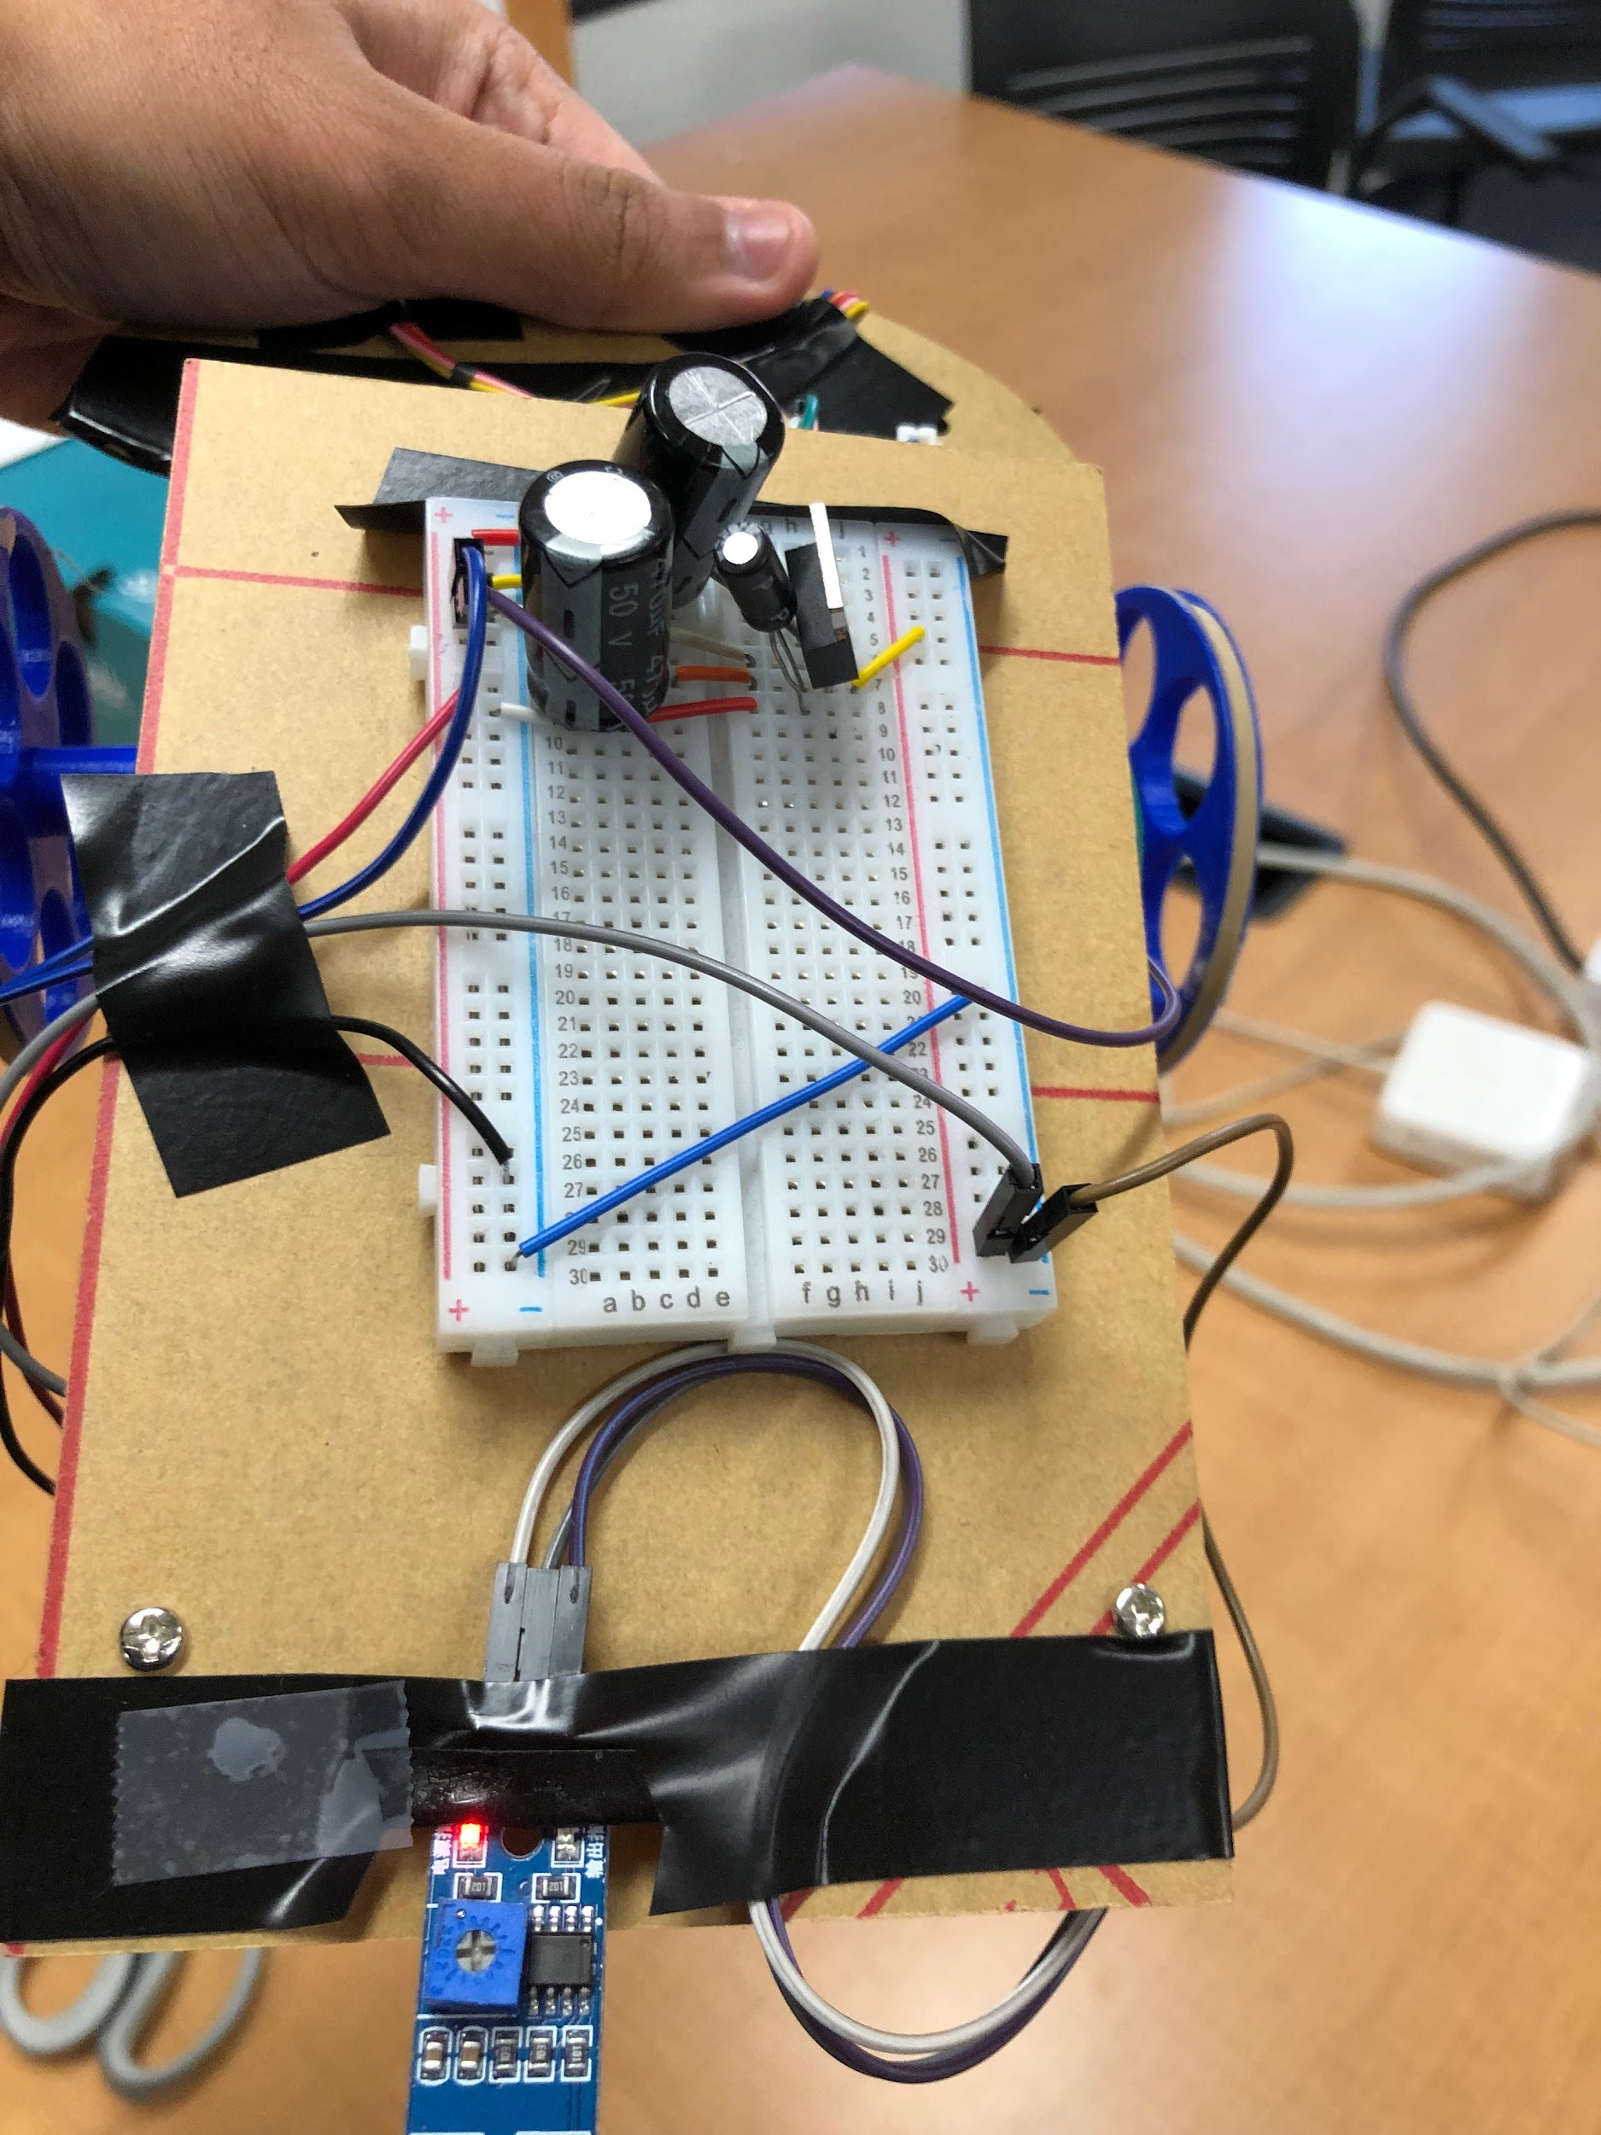

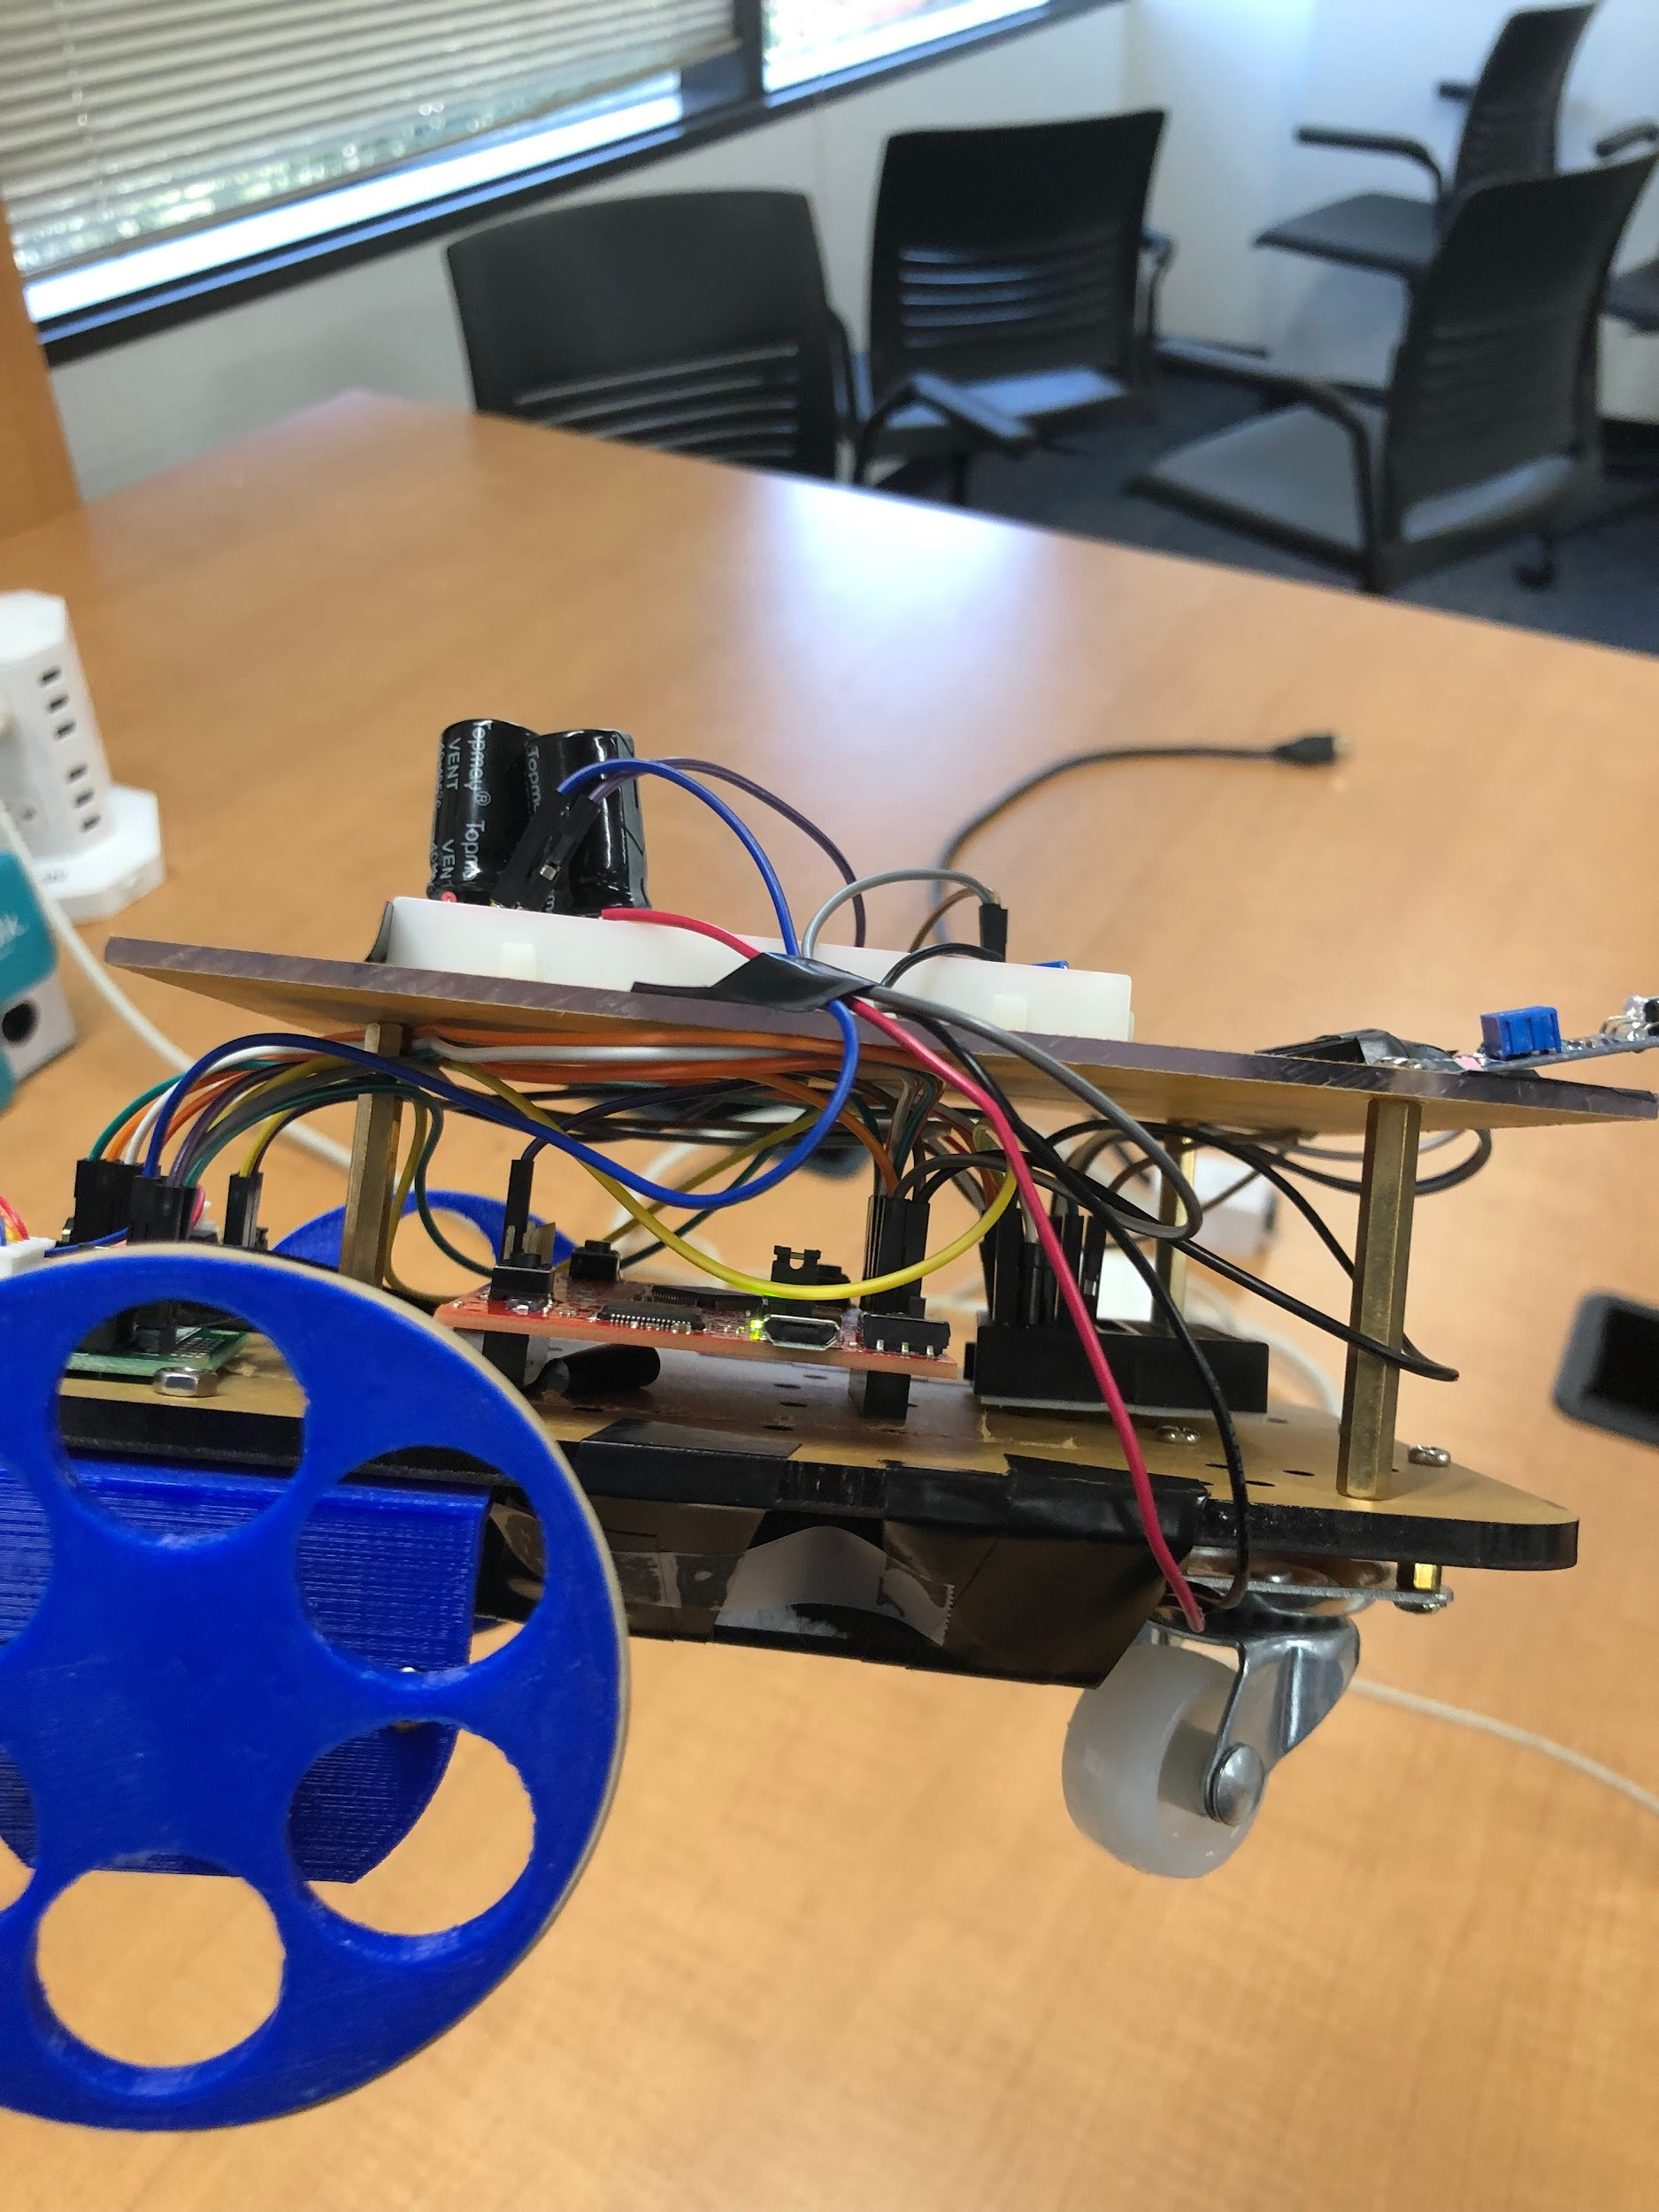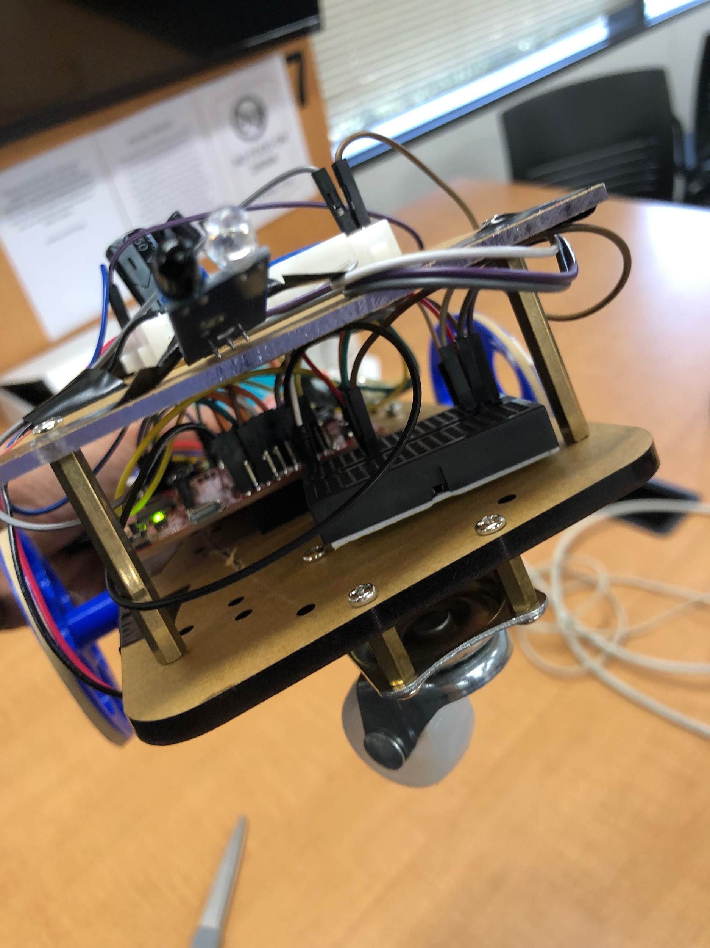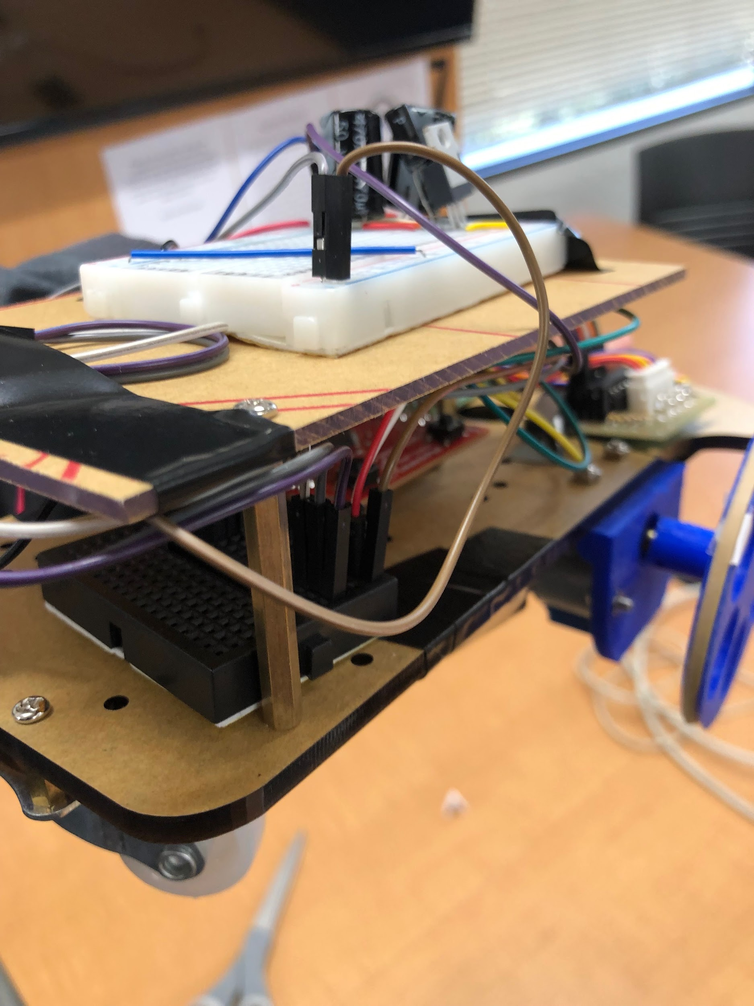Software Design:

An important software component we used was “count” which was a time/check variable for the motors. We implemented the code to where the count variable in a while loop would start at 0 and would add 1 count each loop. In this while loop, we had a for loop which would complete certain movement of the motor each time. Count variable was the key to allowing us to perfect the movement of the car and the garage door to meet the guidelines.

Conclusion:

In conclusion, we combined Project 2 and Project 3 to create this project which simulates a car entering and leaving a garage using components such as sensors, stepper motors, launchpads, a voltage regulator, capacitors, and tons of wires to connect everything together. This project was important because it allowed us to implement something which many people may take for granted. The use of both switches and sensors as input was fun to work with since both have their flaws and appeals. It was also fun to use stepper motors as wheels for the car and as a garage door opener. Overall this was a fun project and we had a great time working on it.